YEAR 11 – PHYSICS 2A2B

ASSIGNMENT 2: FORCES and ENERGY

NAME: DUE DATE: 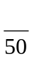

1. A child of mass 25.0 kg slides down a playground slide from rest in 3.20 s. The force acting down the slide is 125 N and a frictional force of 35.0 N acts against the child.

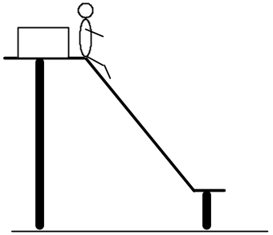
a) Calculate the acceleration of the child down the slope.
(3)

b) Determine the velocity of the child at the bottom of the slide.
(2)

2. A 2000 kg aeroplane is in level flight at 50 m/s. It experiences drag forces due to air resistance totalling 1500 N. The propeller supplies enough force for the plane to increase its speed to 80 m/s in 15.0 s. Assume that the drag forces remain constant.

- Calculate the net force on the plane.
(2)

- Draw a vector diagram to show the forces on the plane.
(3)

- Calculate the force supplied by the propeller.
(2)

3. An iron ore train is being assembled in Port Hedland, ready to be sent to pick up ore from Tom Price. Two engines of combined mass 5.10 x 10⁵ kg moving at 1.00 ms⁻¹ shunt and join with 10 empty ore cars, each of mass 2.40 x 10³ kg.

a) Calculate the speed of the combination immediately after the impact.
(4)

b) Is mechanical energy conserved in this collision? Justify your answer by calculation.
(3)

4. On a building site in Perth, a crane lifts a 1.00 tonne cradle full of 4.00 tonnes of cement off the ground to take it up to the 25th floor. It accelerates upwards from the ground at 1.50 ms⁻² for 4.00 s before maintaining its speed up to the 20th floor. It then decelerates uniformly to a stop at the 25th floor. The total time taken from the ground is 17.4 s.

a) Compare the tension in the single cable holding the cradle when it is accelerating upwards and when it has constant speed.
(5)
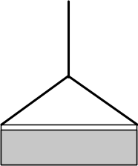

b) Estimate the work done by the crane motor in lifting the cradle up to the 25th floor.
(4)

c) Estimate the average power expended by the motor.
(2)

5. During a tennis game, Aden hits the ball at 40.0 ms⁻¹ (horizontal velocity) directly towards Karina who then hits it straight back at 57.0 ms⁻¹. The 55.0 g ball is in contact with the racquet for 0.115 s.

a) Determine the change in velocity of the ball.
(3)

b) What force is exerted by the racquet onto the ball?
(3)

c) What impulse is acting?
(2)

d) How would you expect the force exerted to change if a racquet with ‘loose strings’ (rather than ‘tight strings’) was used? Explain your answer using the Physics principles involved.
(3)

6. Justin, the archer, fires an arrow (of mass 96.0 g) with a velocity of 1.20 x 10² ms⁻¹ into a target (of mass 1.50 kg) hanging by two light pieces of string from the branch of a tree.

a) If the arrow embeds into the target, what is the velocity of the target immediately after impact?
(3)

b) How high (vertically) does the target and arrow swing?
(HINT: Consider the conservation of energy.)
(3)

c) In reality, will the target and arrow swing this high? Explain your answer in terms of the Physics' principles involved.
(3)

